Infographics as a Creative Assessment
Infographics are a visual representation of data. When students create infographics, they are using information, visual, and technology literacies. This page includes links to help you develop formative or summative assessments that have students creating infographics to showcase their mastery of knowledge.

Short overview of presentation (2:27) | Full presentation (50:00)

Books about Infographics  Eric K. Meyer  Designing Infographics  Hayden Books, 1977  Edward R. Tufte  The Visual Display of Quantitative Information  Graphics Press (2d ed.), 2001  Jenn & Ken Visocky O'Grady  The Information Design Handbook  HOW Books, 2008  Justin Beegel  Infographics for Dummies  IDG, 2014.  General Overview of Infographics  - Definition of an infographic (Ross)  - Infographic about infographics  - Infographics as explained by Legos  - Visual.ly: video  - History of infographics (Rajamanickam)  Infographic Samples  - USA Today Snaphsots  - GOOD: Transparency  - Pouring in your Cup  - Future of Education Technology  - School Libraries and Student Achievement  - Hamburger economics  - AskALibrararian Stats  - In Pursuit of Prose and Poetry (1930's)  - How Common is Your Birthday (NYT data)  - MyPlate.gov  - Resume Timeline  - History of Human Communication  - History of Video Games  - Rising Cost of Public Transport in Australia  - Australian Income and Wealth Distribution  - Lightning  - What is a stock?  - Famous Creases on Cowboy Hats  - 50 Insane Facts about Australia  - Favorite Takeaway Foods 2012  - Conversation Prism  - Kodak Company  - Should I check my email?  - They Draw and Cook  - Carland  - The Trilogy Meter  - iPad Purchase  - Interactive: Flags by Colors  - Interactive: Valuable Sports Franchises  - Newsmap  - Movie: Creating an Infographic  - Infographic World: Portfolio  - Infographics about the Internet  - Internet Statistics  - The Internet in 2020  - How the World Spends Time Online  - The Awesome Evolution of the Net  - The Awesome Size of the Internet  - Is the Net Hurting our Environment?  - Classroom Infographics Samples  - Visual.ly  Literacies and Standards  - Addressing the CCSS with infographics  - Information Literacy Model (SCCC)  - Visual Literacy Standards (ACRL)  - Technology Literacy Standards (ISTE)  - Common Core Standards  - Kathy Schrock's Infographics Rubric  - Additional Rubrics: 1 2 3 4  Student handout for steps in creation  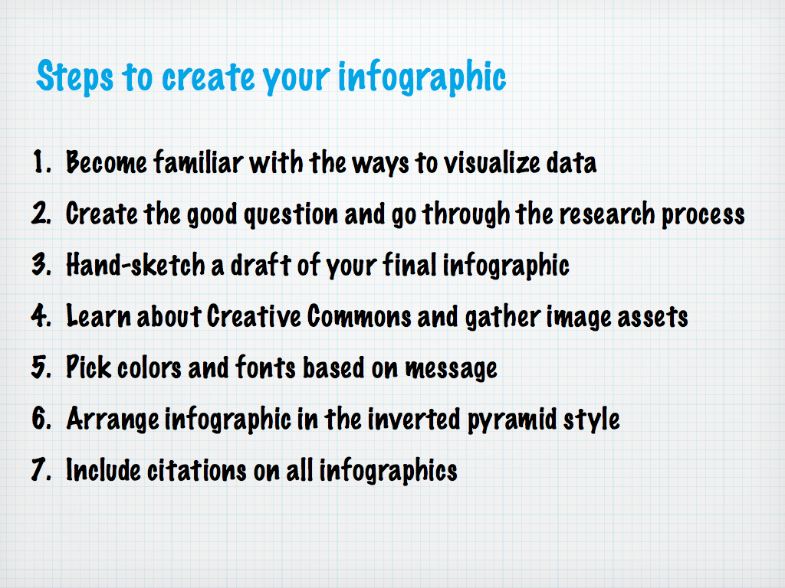  infographic_steps.jpg  Download File  Archives of live presentations  Link to EdWeb presentation (5/9/13)  Link to Slideshare deck from EdWeb  Link to METC2012 stream of presentation  Please note there were two fire alarms that went off during the presentation. We all left for one and came back, and during the second alarm I just talked louder!  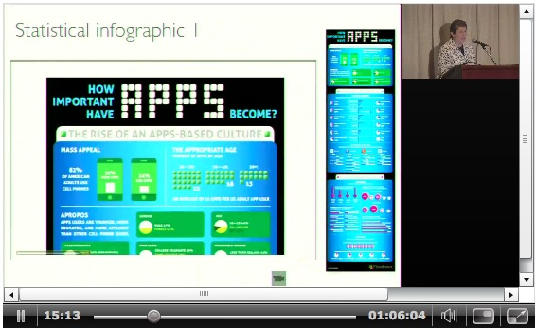  Infographics as explained by Legos  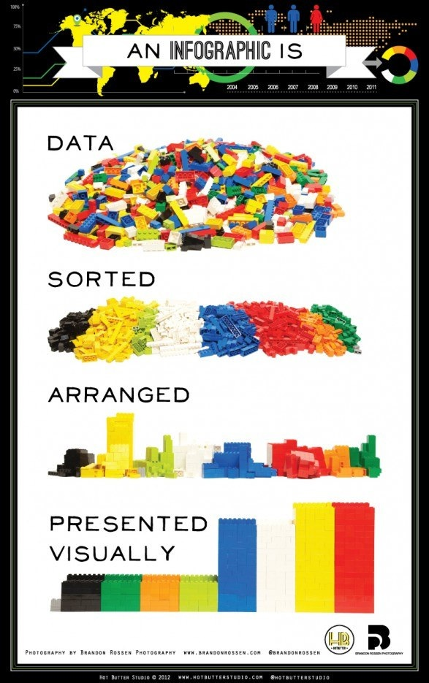  "Will work for iPad" from snagajob.com  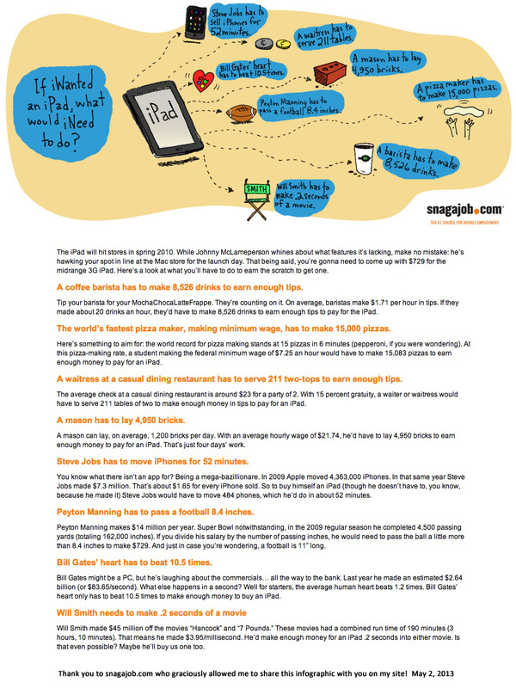 | Creating an Infographic  - Movie: Creating an Infographic 2  - Periodic Table of Data Visualizations  - Information is Beautiful: Data Visualizations  - Chart Chooser  - Many Eyes Visualization Project  - Hohli Online Charts Builder  - How to create your own infographics  - Pictographs: Online tool | Making with Excel  - Hand-drawn infographics  - Netbook  - iPods  - Architecture sketch  - Data  - Creative Commons  - Infographic: Can I use this image?  - Flickr's Creative Commons Search  - Lynell Burmark: Visual Literacy book  - Infographic of Infographics  - Mindscapes: Repeated graphics (Margulies)  - Create an infographic from social media sites  - Vizualize.Me: Resume  - Print Effect  - Twitterize yourself  - Inverted Pyramid Samples  - Starbucks  - The Colors of the Web  - Farmville vs. Farms  - Internet Addiction  - Transforming science education  - Distribution of MOOC's scoreboard  - LATCH Model Samples  - Location  - Alphabet  - Time  - Category  - Hierarchy  - Infographics and Accessibility  - Software, sites, and tools to create infographics  - easel.ly (Web 2.0)  - Glogster (Web 2.0) (example)  - Google Drawings (Web 2.0)  - Grafio Lite (iOS)  - infogr.am (Web 2.0)  - Inkscape (software)  - iVisual Info Touch Lite (iOS) (Android)  - PicCollage (Android) (iOS)  - PicsArt - Photo Studio (iOS) (Android)  - Piktochart (Web 2.0) (example)  - Pixlr (software)  - Quickoffice (iOS) (Android)  - RealtimeBoard (Web 2.0) (Tutorial)  - Sketchpad (Web 2.0)  - SnagIt (software)  - Splashup Lite (software)  - Sumo Paint (Web 2.0)  - Venngage (Web 2.0)  - Visme (formerly Easy Web Presenter) (Web 2.0)  - Visualize (iOS)  - SlideRocket infographic templates  Online Tutorials  Many of the following do not actually address or follow the inverted triangle data presentation style or use the research-based information about color and font, but they are helpful when figuring out how to start.  - How to Create Outstanding Infographics  - 5 Steps to Create a Powerful Visual  - How to Create Infographics  - SIMILE Widgets  - Infographics Design Framework  Using Infographics in the Classroom  - Steps to Teach Infographics  - Essay 2 Infographic Lesson (Coleman)  - NYT: Teaching with Infographics: SSL  - NYT: Teaching with Infographics: ELA/Arts  - NYT: Teaching with Infographics: Sci/Tech  - Diana Laufenberg (SLA): Unit Plan  - Good.is Infographic Design Contest  - Childhood Obesity  - Submissions  - Winners  - Haiti Earthquake Information  - Submissions  - Winners  - New Orleans Infographic  - Submissions  - Winners  - Henrico County Public Schools: Unit Plan  - David Warlick: Infographic-A-Day  - Krauss/Laufenberg ISTE11 Infographics Links  - Fowler and Kinney ISTE11 Infographics Links  - Teacher's First Infographics Resources  - Infographics lesson plan (6-8)  Other cool, useful information and links  - 10 Awesome Free Tools to Make Infographics  - Little Red Riding Hood movie  - David Warlick's DataVis/Infographics Handout  - 40 Insightful Infographics  - Alltop Collection of Infographics Sites  - Chart Porn Data Visualizations  - Personality Infographic Creator  - Create Infographics from Twitter and FB  - Column Five Media Infographics  - iPad/iPhone Infographics App  - Add your student's infographics to Flickr group  - Google Docs Infographic Template  - Characteristics of Effective Infographics  - Five ways to visualize information (Schrock)  - Infographics resources  - Kinzaa: Build your infographic resume  - A Media Specialist's Guide: Infographics  - NHRDC Infographics PD  - Infographics and the Common Core  - Embed infographics in a Web site or blog  - The great infographics debate  - Infographics by subject  - E-learning infographics  Sources of data sets for infographics  - Statistics sites on the Web  - Data.gov: raw data  - Freebase from Google  - State data projects: CA | Utah  Infographics for advocacy & promotion  - Infographics for advocacy (movements.org)  - School librarian data | SAT data  - UN education advocacy infographic  - PInterest boards 1 | 2  - Advocacy sample: 1 | 2 | 3 | 4 | 5 | 6  - Promotion samples: 1 | 2 | 3 | 4 | 5  - John Emerson booklet on infographic advocacy  infodesign.pdf  Download File  Infographics Lesson Plan by A. Stryker  infographics_lesson.zip  Download File  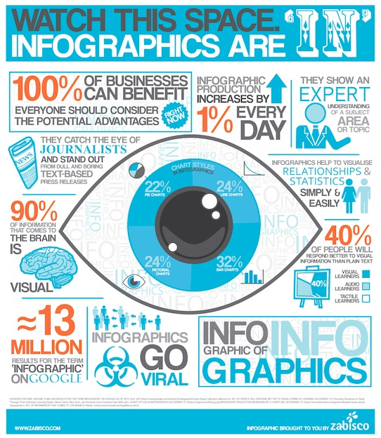  http://www.zabisco.com/blog/?p=2766  Infographics: Analyze, Evaluate and Create from Linda Nitsche

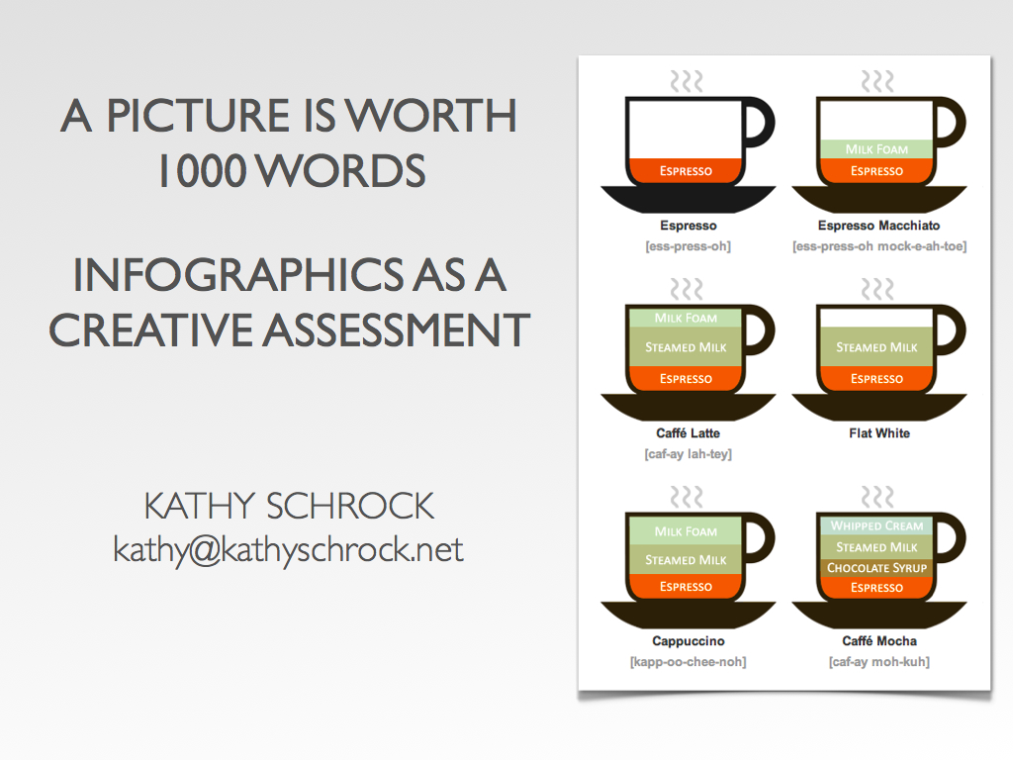

LIST OF INFOGRAPHIC TOPICS
There are hundreds of infographics on the Web. One fun activity is to conduct a Google phrase search of "topic infographic" or "infographic about topic" and see what shows up!
Here is a list of topics to start with that will lead you to some very cool infographics!
01. Education infographic  02. Computer infographic  03. Coupon infographic  04. iPad infographic  05. Coffee infographic  06. Twitter infographic  07. Facebook infographic  08. Movie infographic  09. Financial infographic  10. Fast food infographic  11. College infographic  12. Automobile infographic  13. Immigration infographic  14. Consumer spending infographic  15. Disease infographic  16. Dog infographic  17. Football infographic  18. Presidents infographic  19. Debt infographic  20. Resume infographic | 21. NCAA infographic  22. Cooking infographic  23. Internet infographic  24. Green infographic  25. Apps infographic  26. Infographic infographic  27. Population infographic  28. Apple infographic  29. Microsoft infographic  30. Higher ed infographic  31. Email infographic  32. Election infographic  33. Math infographic  34. Communication infographic  35. Social media infographic  36. Teacher infographic  37. Travel infographic  38. Industrial infographic  39. Space infographic  40. Television infographic

INFOGRAPHICS WORKSHOP PAGE (passworded)

SAMPLE INFOGRAPHICS FROM WORKSHOPS

Ohio Educational Library Media Association (OELMA)
This group of school library teachers created advocacy infographics taken from returned survey data of Ohio public elementary school librarians.
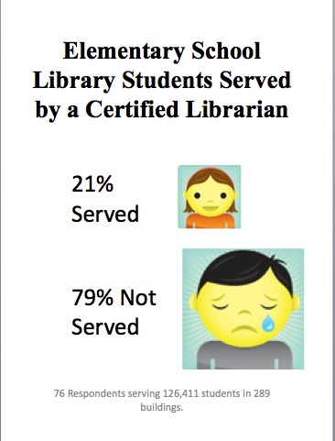
1 | 2 | 3 | 4

Northside (TX) ISD
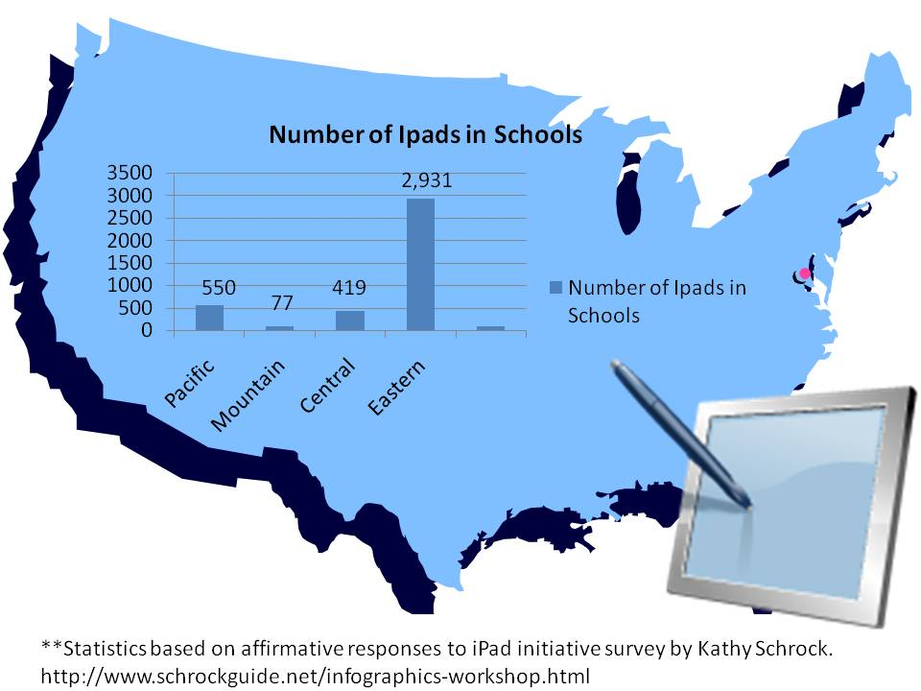
1 | 2 | 3 | 4 | 5 | 6 | 7 | 8 | 9 | 10

Samples from other workshops, some completed only using an iPad
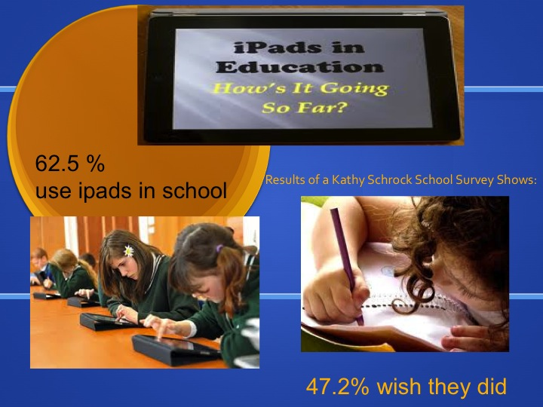
TLA 2012
1 | 2 | 3 | 4 | 5 | 6 | 7 | 8 | 9 | 10 | 11 | 12 | 13 | 14 | 15

This work by Kathy Schrock is licensed under a Creative Commons Attribution-NonCommercial-NoDerivatives 4.0 International License. | Kathy Schrock (kathy@kathyschrock.net)  URL: http://schrockguide.net/infographics-as-an-assessment.html  Page created: 10/01/2010  Last updated: 05/26/2014

